**1.INTRODUCTION**

**1.1 Overview**

An index of economic freedom measures and ranks countries according to relevant standards judged by the creators of the index. Not all economists will agree on the relevant criteria, of course.

Indices of economic freedom consider free-market economies at the high-end of the spectrum for analysis. There is a firm correlation between both the earnings a country’s citizens enjoy and the index of economic freedom ranking of such country.

**1.2 Purpose**

Economic freedom is the fundamental right of every human to control his or her own labour and property. In an economically free society, individuals are free to work, produce, consume, and invest in any way they please.

The cornerstones of economic freedom are :

* personal choice,
* voluntary exchange coordinated by markets,
* freedom to enter and compete in markets, and
* protection of persons and their property from aggression by others.

**2. UNDERSTAND THE INDEX OF ECONOMIC FREEDOM**

An index of economic freedom measures and ranks countries according to relevant standards judged by the creators of the index. Not all economists will agree on the relevant criteria, of course.

Indices of economic freedom consider free-market economies at the high-end of the spectrum for analysis. There is a firm correlation between both the earnings a country’s citizens enjoy and the index of economic freedom ranking of such country. Investors can use the index of economic freedom as a faster way to observe the changes in economies.

Using the Economic Freedom Index, users can discover innovative ways to use the index in science, public policy, enterprise, and advocacy. The index is an excellent analytical tool for evaluating 186 economies worldwide, and each country page is a platform for examining the political and economic trends of a nation in depth

**2.2 Types of index of economic freedom**

Principal varieties of this index include free, mostly free, moderately free, moderately free, mostly unfree, primarily unfree, and repressed.

**3.RESENT UPDATES ABOUT THE INDEX OF ECONOMIC FREEDOM**

In the Index of Economic Freedom 2019, an annual guide published by The Heritage Foundation, Washington’s No. 1 think tank, the ideals of economic freedom which fuelled this impressive progress was again calculated.

Over recent years, economic freedom’s top countries have been relatively consistent. In 2019, Hong Kong ranked number one with a score of 90.2 overall. Singapore (89.4), New Zealand (84.4), Switzerland (81.9), Australia (80.9), and Ireland (80.5) followed to round out the economies classified safe.

**4.PROBLEM DEFINITION AND DESIGN THINKING**

**4.1 Empathy map**

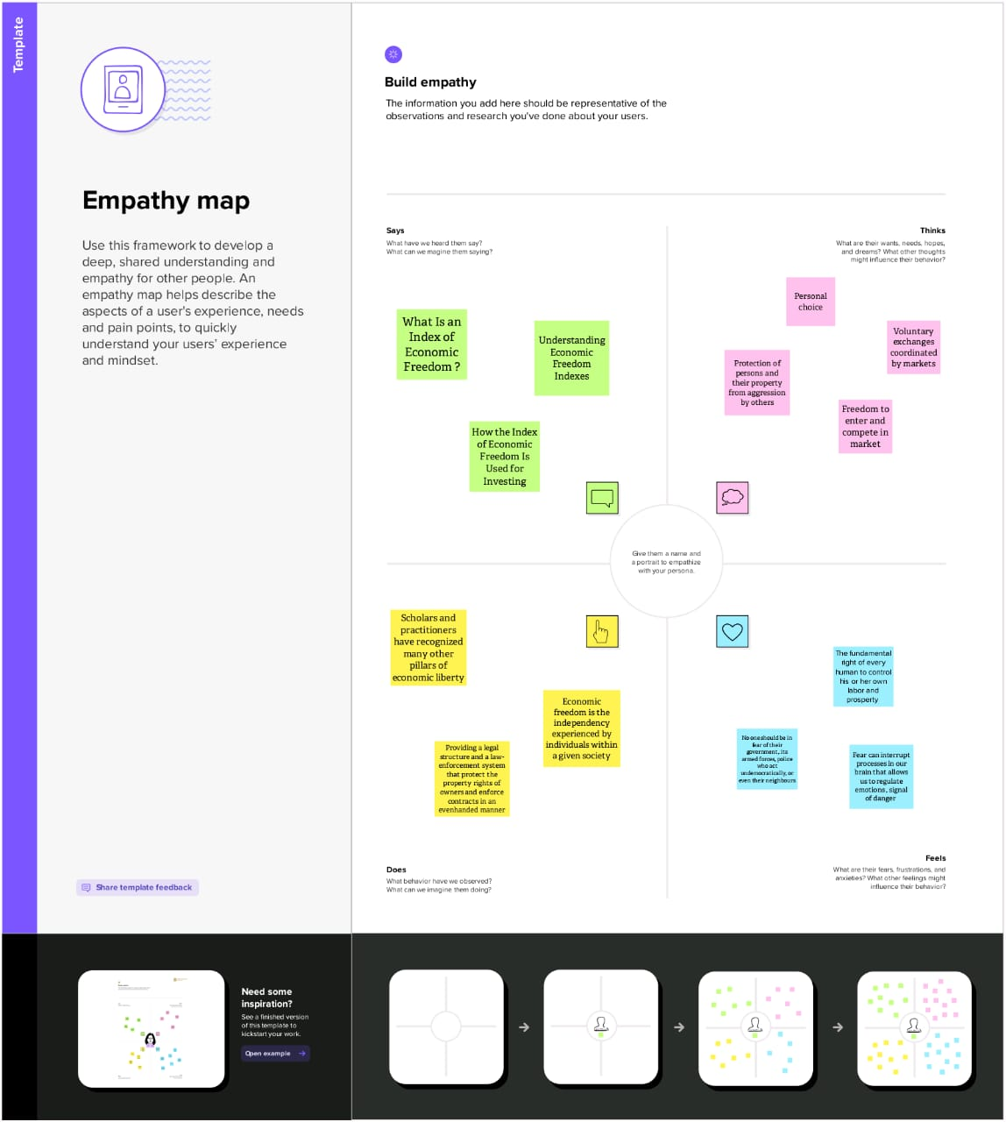

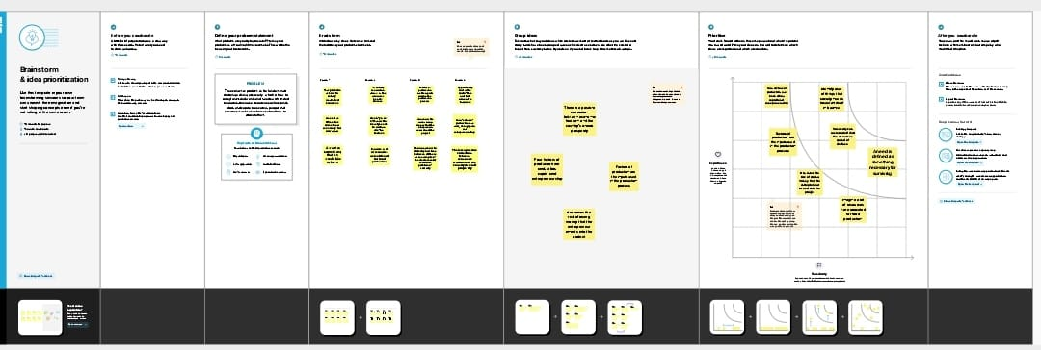**4.2 Ideation and brainstorming**

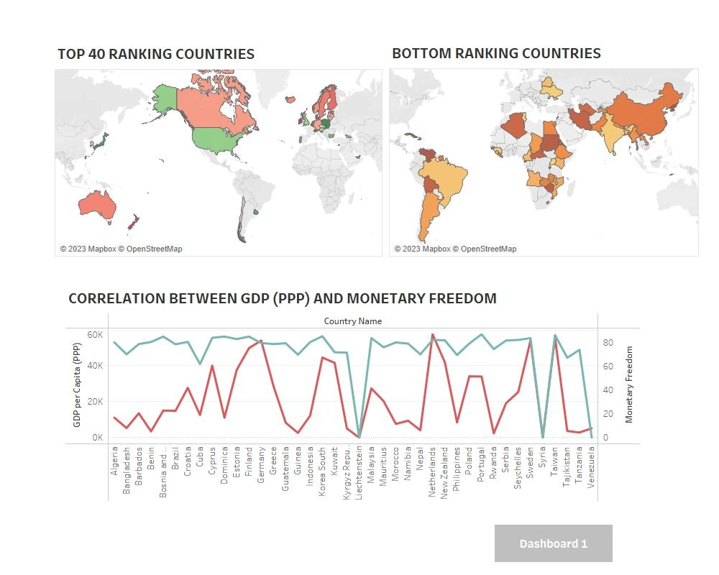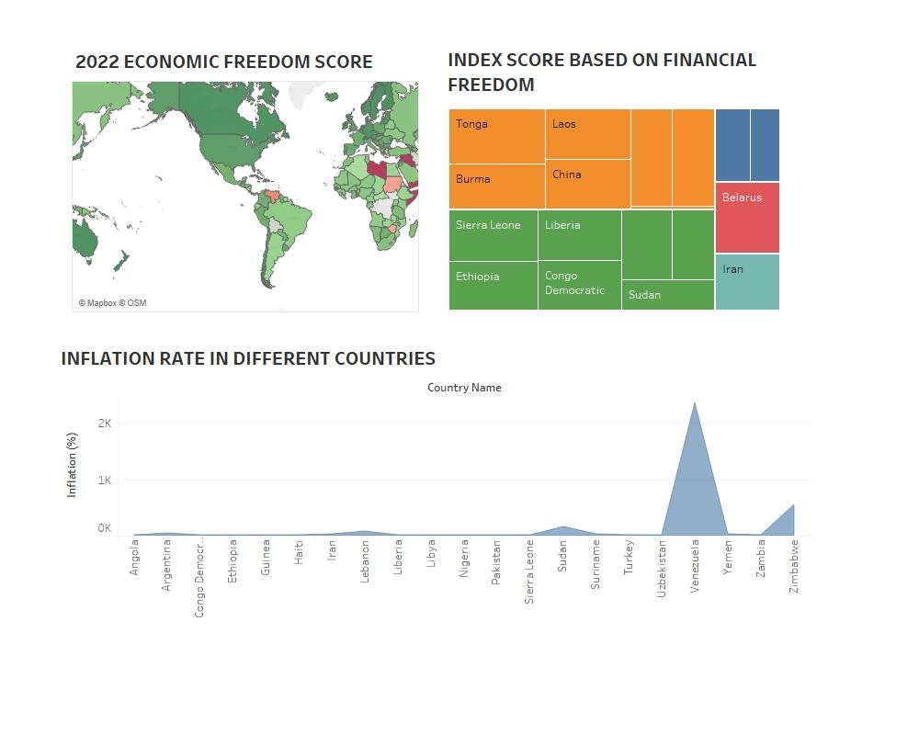**5. RESULT**

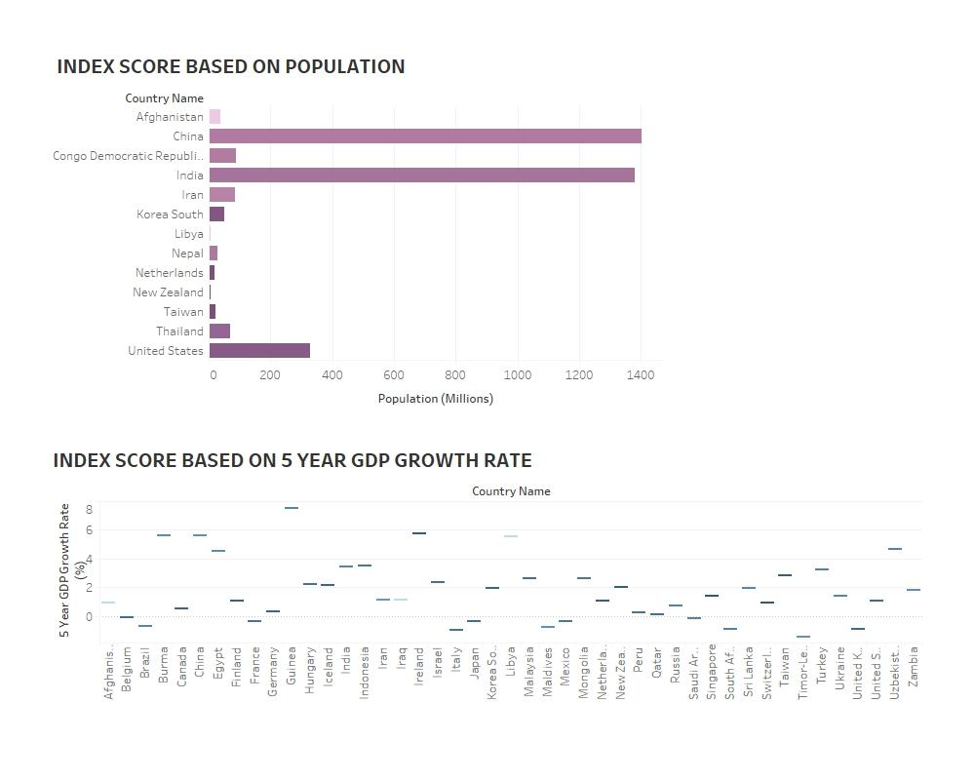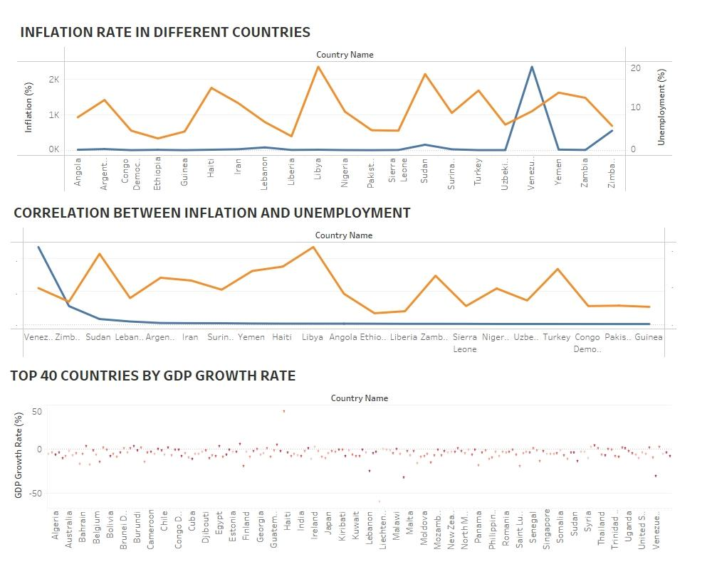

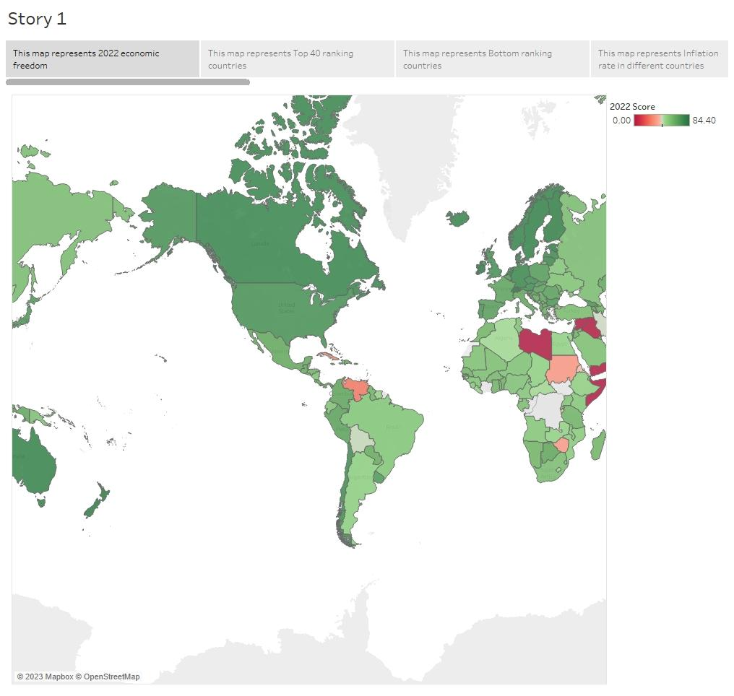

**6. ADVANTAGES AND DISADVANTAGE**

The advanced and relatively free countries are essential to generating the opportunities of backwardness. They provide a model, a source of technology, and a market for low wage products.

If the advanced countries became rich ahead of other countries because they established safe property rights for merchants and producers earlier than others, because they benefited from limited government earlier than others, because they invented capitalism and benefited from economic freedom first, then the advantages of backwardness are the effect of economic freedom or capitalism.

Unfortunately, a lack of quantitative data prevents us from analysing the impact of economic freedom on growth rates in the long run. But it is plausible to base a claim on qualitative data or narratives according to which the impact of economic freedom is strong.

The advantages of backwardness must have been small before the establishment of capitalism because most major civilizations (comprising tens of millions of people) then still had rather similar per capita incomes.

**6. APPLICATIONS**

The index evaluates 177 countries in four broad policy areas that affect the economic freedom, which are rule of law, government size, regulatory efficiency and open markets. It also takes into consideration some specific categories like property rights, judicial effectiveness, government integrity and tax burden.

**7. CONCLUSION**

Economic freedom is the fundamental right of every human to control his or her own labor and property. In an economically free society, individuals are free to work, produce, consume, and invest in any way they please.